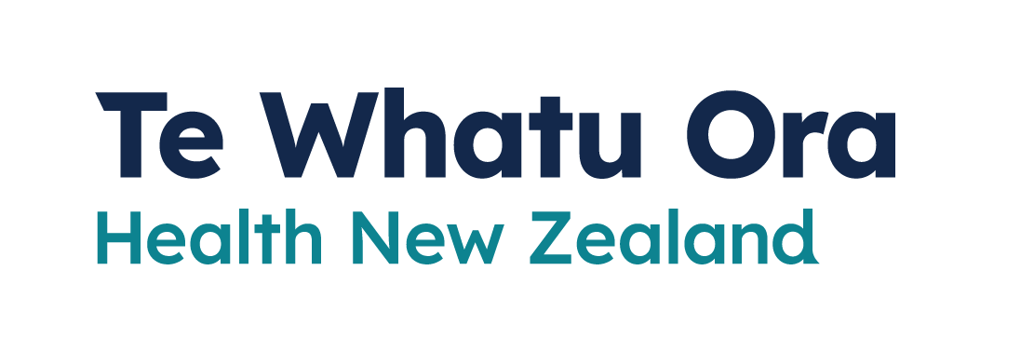

Help and support
Adapted in 2023 by Accessible Formats Service,
Blind Low Vision NZ, Auckland
TN: There are two logos at the top of the page. On the left is: Te Kāwanatanga o Aotearoa New Zealand Government. On the right is: Te Whatu Ora
Health New Zealand.

Help and support
Most people will be able to manage isolation with help from whānau and friends, but there may be help available for you and your household if you need it.
If you are eligible, you may be able to get money to pay for urgent and essential costs, like food, medicine and some bills.
If you need help with urgent costs, or have to take unpaid leave, you may be eligible for support from Work and Income:
- check at www.workandincome.govt.nz/, or
- call 0800 559 009.
Your local community organisations, for example, foodbanks, may be able to help you if you need further support.
The COVID-19 disability helpline can provide help or information about vaccines, face mask exemptions, testing, managing COVID-19, and any other health concerns you may have. This includes if your support worker or carer is unavailable. Call 0800 11 12 13 for free. If you are unable to call, you can text 8988.
The COVID-19 welfare phone line can help if you are self-isolating and need food or other essential items.
Call 0800 512 337.
You can also call Healthline for free for advice on
0800 358 5453.
COVID-19 has taken a toll on everyone's mental health. Effective mental health tools are available to help people recover from the impact of the pandemic.
To find more information about looking after your mental wellbeing, go here: www.covid19.govt.nz/MentalWellbeing
End of Help and support

