
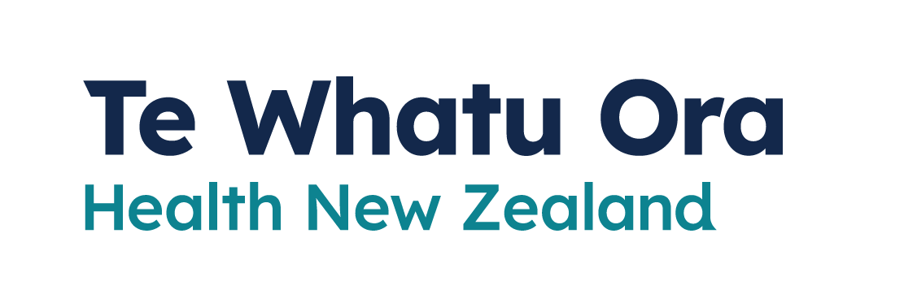
Medicines to treat COVID-19
Adapted in 2023 by Accessible Formats Service,
Blind Low Vision NZ, Auckland
TN: There are two logos at the top of the page. On the left is: Te Kāwanatanga o Aotearoa New Zealand Government. On the right is: Te Whatu Ora Health New Zealand.

Medicines to treat COVID-19
COVID-19 antiviral medicines can help people who are at risk of becoming very sick with COVID-19. These medicines are free. You must start taking them within the first 5 days of becoming unwell.
Some people with a higher risk of severe illness from COVID-19 are eligible for treatment with COVID-19 antiviral medicines. These medicines reduce the amount of virus in your body, so you do not get as sick and you are less likely to go to hospital.
You can get a prescription for antivirals from your doctor or hauora provider. Some pharmacies can supply antivirals without a prescription.
COVID-19 antiviral medicines are available to treat early COVID-19 at home. These include:
- ritonavir with nirmatrelvir (branded as Paxlovid)
- molnupiravir (branded as Lagevrio).
Molnupiravir is no longer recommended. Paxlovid continues to be recommended for people who are at higher risk of severe illness from COVID-19. When taken within the first 5 days of your COVID-19 illness Paxlovid can help you stay out of hospital.
You can get free antiviral medicines if you:
- have COVID-19 and symptoms or you are a Household Contact and have symptoms, and
- became sick within the last 5 days, and
- meet one of the additional antiviral eligibility criteria.
Eligible people include:
- Māori or Pacific people aged 50 or over
- everyone aged 65 or over
- anyone aged 50 or over, who has not completed a primary course of vaccination
- anyone with a severely weakened immune system
- anyone with Down syndrome
- anyone with sickle cell disease
- anyone who has previously been in critical high dependency hospital care from COVID-19
- anyone with a disability who is at high risk of severe illness from COVID-19
- anyone with frailty or vulnerability due to one or more severe health conditions
- anyone with 3 or more high-risk medical conditions.
Talk to your doctor, pharmacist or hauora provider if you think that you, or a member of your whānau may be eligible for antiviral medicines.
If you are at risk of becoming very unwell with COVID-19 you may be able to get a prescription before you get COVID-19. This means the pharmacist will have the prescription ready to use if you become unwell. You will not be able to get the medicine until you test positive for COVID-19.
Talk to your doctor, pharmacist or Hauora provider to see if getting a prescription before you get unwell is right for you.

If you need support
- The COVID-19 disability helpline can provide help or information about vaccines, face mask exemptions, testing, managing COVID-19, and any other health concerns you may have.
Call 0800 11 12 13 for free. If you are unable to call, you can text 8988.
- The COVID-19 welfare phone line can help if you are self-isolating and need food or other essential items. Call 0800 512 337.
- You can also call Healthline for free for advice on 0800 358 5453.
End of Medicines to treat COVID-19

